Predicting Customer Purchase Behavior Using Machine Learning Algorithms for Personalized Marketing Strategy Development

Abhijith Binu [20332030]  Department of data science  University of Europe for Applied Sciences  Potsdam, Germany  abhijith.binu@ue-germany.de | Talha Ali Khan  Department of Business  University of Europe for Applied Sciences  Potsdam, Germany  talhaalikhan@ue-germany.de | Raja Hashim Ali  Department of Business  University of Europe for Applied Sciences  Potsdam, Germany  hashim.ali@ue-germany.de

Abstract— The customer purchasing behavior has become an important aspect in a data-driven business environment to build personalized marketing strategies. Old fashioned marketing approaches are unable to handle large online customer data, therefore failing to target and personalize effectively. The paper will fill the gap by testing machine learning (ML) models (Logistic Regression, Random Forest, SVM, MLP, XGBoost, and LightGBM) on an open-source dataset of ~3,900 customer records available on Kaggle. The article will feature preprocessing, a binary labeling of the targets with a threshold of 50, and an accuracy, precision, recall, F1-score, and AUC calculations on the models. Findings suggest that models involved in simple models like Logistic Regression and MLP are sometimes better performers than bigger models like XGBoost when it comes to smaller datasets and are more interpretable. Explainability is done by using SHAP and LIME. The result augments the marketers with practical knowledge and assists in ethical and scalable adoption of ML in their marketing strategy design.

INTRODUCTION
A. Gap Analysis
Although machine learning (ML) has greatly simplified the use of machine learning to perform marketing analytics, it has numerous gaps that have not been filled. The majority of the already developed research focus on precision and do not measure the interpretability of the results and are based on complicated ensemble modeling strategies without focusing on their explainability in the real world. Moreover, existing studies based on proprietary data do not allow reproducing, generalizing, and hence, do not facilitate knowledge advancement. Such behavioral identifiers as purchase history, subscriptions, and review rating are not used as much as plain demographic data. And hardly any bridge the gap between technical model output and business strategy to act on. These limitations interfere with implementing dependable and moral ML systems in the actual marketing settings to forecast customer purchase.

C. Research Questions
The study will generally satisfy a burning need of interpretable and efficacious ML-based solutions to predict customer behaviour.
- How can ML algorithms be applied effectively to predict customer purchase behavior using open-access consumer data?
- Which ML models provide an optimal balance between prediction accuracy and model interpretability?
- How can the predictions from ML models be integrated into actionable, personalized marketing strategies?

B. Problem Statement
The inability to develop data analysis capability leads to inability of long-standing marketing approaches to track dynamic and individual-level consumer behavior. Such a problem as determining the high-value purchase behavior is solved in this study based on applying the machine modeling to the structured behavioral and transactional data, and at the same time such a feature as allowing the interpretation of the prediction in implementable way of marketing decision-making.

D. Novelty of this study
This study presents a hybrid approach combining predictive modeling with explainable AI to bridge the gap between technical accuracy and business usability.
- Novelty 1: Integrates SHAP and LIME for interpreting black-box models in marketing.
- Novelty 2: Uses a publicly available, behavior-rich dataset for transparent validation.
- Novelty 3: Links prediction outputs directly with business strategy recommendations.

E. Significance of Our Work
By combining interpretable ML models with business-contextual insights, this study empowers marketers to build targeted, ethical, and data-driven strategies [3]. The findings confirm that even such a simple model as Logistic Regression and MLP can achieve very good performance in comparison to complex algorithms, but only with the help of feature selection and explainability tools that guarantee their practical implementation in real-life application.

LITERATURE REVIEW
Over the past couple of years, there has been an upsurge in the application of machine learning (ML) strategies to investigate customer shopping patterns in the sphere of predictive marketing. These methods will make it easy to get past demographic-based segmentation, and realize the power of behavioural and transactional data. Central ML methods to apply in this field consists of classification models, Logistic Regression, or ensemble methods, Random Forest or XGBoost, and deep learning networks, Multi-Layer Perceptrons. Moreover, as the desire to have transparency rises, explainable AI algorithms such as SHAP and LIME have become popular to investigate the black-box models. This part discusses the history of these key methods and their additions and the way in which they complement individualized marketing success.
- Logistic Regression and Decision Trees
One of the first and most understandable marketing analytics classification techniques is the Logistic Regression (LR). The study by [1] shows that LR models have been practical in the identification of customer churn in e-commerce sites providing probabilistic information on purchase-prone behaviors. On the same note, [2] used LR and ensemble models in predicting purchase intent with particular focus on LR as a good baseline in comparative tests. [6] used LR in classifying purchase of the consumers and reported that the approach returned consistent performance at very low computation expense. Moreover [25] said that LR transparency helps in building confidence and responsibility to AI-powered personalization systems.
Decision Trees (DTs), on the other hand, offer rule-based interpretability by splitting decisions on feature thresholds. [16] showed that DTs helped in segmenting customer profiles for personalized targeting, with clear visualization of decision rules. [31] leveraged DTs for modeling digital consumer loyalty and demonstrated their ease in explaining loyalty-based predictions. [27] noted that DTs are especially useful in business scenarios where model explainability is prioritized. [11] used DTs in conjunction with behavioral data to enhance return on investment (ROI) through data-driven marketing.
- Random Forest and Ensemble Models
Random Forest (RF), a bagging ensemble method, has gained popularity for its robustness and generalization capability. [4] highlighted RF’s effectiveness in e-commerce analytics, where combining multiple decision trees improved classification of customer segments. [9] used RF to predict consumer engagement and emphasized its capacity to avoid overfitting in high-dimensional datasets. [14] assessed RF alongside explainable AI tools and found SHAP could successfully decompose RF decisions into understandable feature contributions. [10] also verified RF’s performance and reliability in predicting purchase behavior across diverse customer profiles.
Gradient boosting ensembles such as XGBoost and LightGBM have been widely adopted for their predictive power and efficiency. [3] used XGBoost in financial marketing applications and reported enhanced precision in customer targeting. [15] compared LightGBM with other boosting models and demonstrated its computational superiority while maintaining high accuracy. [17] incorporated feature importance from boosted models to create more cost-effective marketing strategies. [13] applied transformer-inspired models alongside boosting to improve purchase timing prediction, highlighting the scalability of ensemble methods for large e-commerce datasets.
- Deep Learning and Multi-Layer Perceptron (MLP)
Deep learning techniques, particularly Multi-Layer Perceptrons (MLPs), are increasingly used to uncover complex, non-linear relationships in customer data. [5] Combined MLPs with decision-making frameworks like DEMATEL to analyze feature preferences, achieving high accuracy in modeling purchase intentions. [11] Implemented multitask learning with deep neural networks and improved behavioral prediction across multiple customer targets. [14] Emphasized the role of MLPs in increasing model sensitivity while cautioning that such architectures often require additional interpretability tools to be practically useful. [25] applied deep learning in fashion retail marketing and demonstrated how MLPs adapted well to changing customer trends and preferences.
However, challenges remain in deep learning's applicability, including lack of transparency and risk of overfitting, particularly on small datasets. [35] conducted comparative evaluations and found that while MLPs outperformed simpler models in high-volume data contexts, they often required substantial tuning and domain expertise to generalize well. This trade-off between performance and interpretability continues to shape the choice of models in real-world marketing deployments.
- Explainable AI: SHAP and LIME
As machine learning becomes deeply embedded in decision-making, the need for transparent and interpretable models has grown. SHAP (SHapley Additive exPlanations) and LIME (Local Interpretable Model-agnostic Explanations) have emerged as leading frameworks to explain model predictions. [29] discussed SHAP's mathematical grounding in game theory, emphasizing its consistency and fairness in feature attribution across tree-based models. [28] compared SHAP and LIME, showing that SHAP offers better global understanding while LIME excels at local, instance-level interpretation.
[23] integrated SHAP and LIME in industrial applications and verified that these tools enhanced user trust, especially in high-stakes environments. [22] used both tools in energy forecasting and demonstrated their role in refining feature engineering through visual explanations. In marketing, SHAP values help marketers understand which behavioral factors most influence high-value purchases, while LIME supports one-on-one customer targeting by justifying individual recommendations.
The dual use of SHAP and LIME not only satisfies ethical requirements but also enables practical deployment of black-box models like XGBoost and MLP in business settings [37]. These tools bridge the technical-business divide, ensuring that model outputs align with stakeholder expectations.
This literature review demonstrates that while a variety of ML models have been explored in the context of marketing, many studies overlook the explainability, business applicability, and ethical integration of these methods [36]. These kinds of limitations have been surpassed in the present study, with the use of end-to-end modeling pipeline, which not only makes accurate predictions of the customer behavior, but also justifies each prediction soundly-providing transparent, data-driven, ethical decisions on marketing.

METHODOLOGY
The study introduces an organized approach that can be used to predict the customer buying behavior by applying different machine learning ( ML ) models [27]. The methodology incorporates data acquisition and preprocessing of consumer data, the development of a target variable formed on the basis of purchase importance, the training of several ML classifiers and their assessment, evaluated with the help of clear metrics. Besides, explainability tools like SHAP and LIME are somehow integrated in the model to make model predictions interpretable.
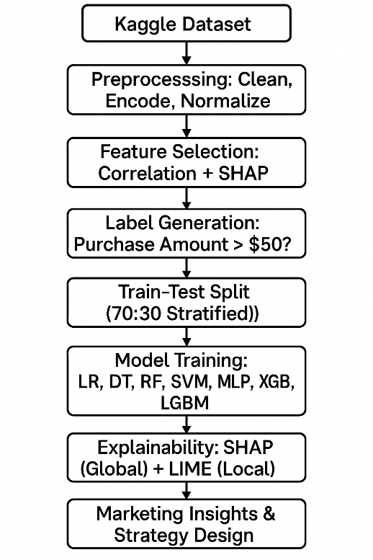
Figure 1: Overall Workflow for Predicting Customer Purchase Behavior
- Dataset
The data to be used occasioned by this research is the publicly available Kaggle dataset: the Consumer Behavior and Shopping Habits. It comprises 3900 records each one of which reflects the customer transaction [10]. The data has 18 columns that contain Age, Gender, Review Rating, Previous Purchases, Payment Method, and Subscription Status. These features span both demographic and behavioral attributes and allow for in-depth analysis of consumer decision-making patterns.
Each entry provides transactional-level insights that include Purchase Amount (USD), Product Category, Promo Code usage, and Location. As the dataset does not contain personally identifiable information (PII), it meets ethical data usage standards.
- Detailed Methodology
The methodological pipeline adopted in this study is divided into several key stages:
- Data Preprocessing:
The raw dataset underwent rigorous preprocessing to ensure data integrity and model compatibility. Missing values were handled by eliminating rows with null entries. Categorical variables (e.g., Gender, Payment Method) were label-encoded to enable use in numerical ML models. Continuous variables such as Age and Purchase Amount were standardized using Z-score normalization to stabilize the scale and improve model convergence [35]. Outliers were detected using boxplots and addressed to avoid skewing results.
- Target Variable Construction:
The initial data did not include a binary target, so we designed our own by creating a classification variable via imposing a $50 boundary around the attribute called “Purchase Amount (USD)”. They coded transactions of more than 50 as 1 (HVpurchase: High value Purchase) and less than 50 or 50 as 0 (LVpurchase: Low value Purchase). This business-based threshold will enable companies to know the difference between serious buyers and those who are beaters [34]. This also recast the issue as a supervised binary classification problem, which made sense when it came to many ML algorithms.
- Model Training and Interpretability:
Multiple ML models were selected based on their popularity and varying complexity. These included:
  - Logistic Regression (LR)
  - Decision Tree (DT)
  - Random Forest (RF)
  - Support Vector Machine (SVM)
  - Multi-Layer Perceptron (MLP)
  - XGBoost (XGB)
  - LightGBM (LGBM)
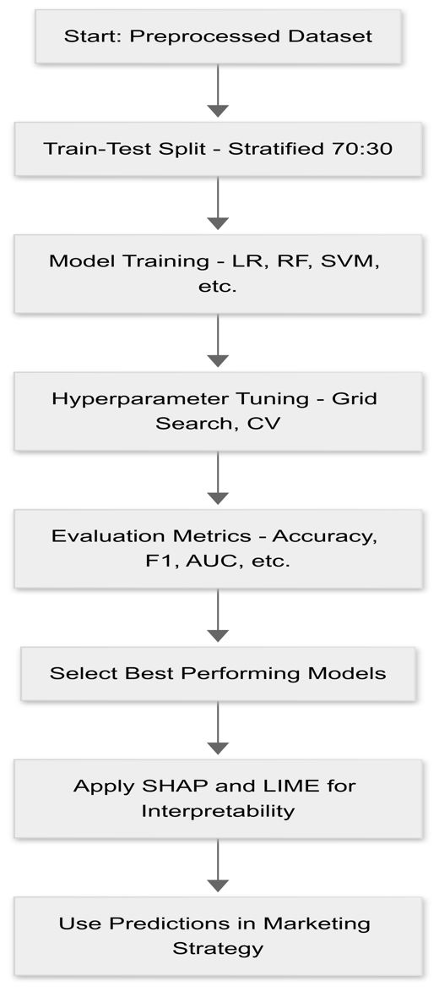
Figure 1: Machine Learning Model Training & Validation Pipeline
The stratified 70:30 split training and test sets were used to train each model to maintain the ratio between classes. The grid search and cross-validation were used to optimise hyperparameters where possible.
In order to enhance interpretability, SHAP (SHapley Additive Explanations) was deployed to present both global and local feature importance, and LIME (Local Interpretable Model-Agnostic Explanations) deployed to explain individual predictions.

- Evaluation Metrics
To evaluate model performance rigorously, we used the following metrics tailored to the problem of binary classification:
Accuracy: Measures the percentage of correctly predicted transactions out of total transactions.
$$Accuracy=\frac{TP+TN}{TP+TN+FP+FN}​$$
Precision: Indicates how many predicted high-value purchases were correct.
$$Precision=\frac{TP}{TP+FP}​$$
Recall: Represents how many actual high-value purchases were correctly identified.
$Recall=\frac{TP}{TP+FN}$​
F1 Score: Harmonic mean of Precision and Recall, useful in case of imbalanced classes.
$$FF1=2×\frac{Precision⋅Recall}{Precision+Recall}$$
Area Under Curve (AUC): Measures the model's ability to distinguish between the two classes across thresholds.
The plots of confusion matrices were also created to see the mistakes in classes and also giveroom to actions that address the mistakes made.

- Experimental settings

All experiments were conducted using Python 3.9 in a Jupyter Notebook environment. Key libraries included:
- Scikit-learn: For baseline models and evaluation.
- XGBoost & LightGBM: For advanced ensemble models.
- SHAP & LIME: For explainability.
- Pandas, NumPy, Seaborn, Matplotlib: For data handling and visualization.
Training and testing were done using stratification in the ratio of 70:30. To reproducibility, random seed was set. The feature selection was carried out by the methods of correlation matrix analysis and SHAP feature importance [33]. During tuning hyperparameters, 5-fold cross-validations were used to validate models.
TABLE I
Hyperparameter Settings Table
Model | Key Hyperparameters
Logistic Regression | Penalty = L2, C = 1.0
Decision Tree | Max Depth = 5, Min Samples Split = 10
Random Forest | Estimators = 100, Max Depth = 7
SVM | Kernel = 'rbf', C = 1.0
MLP | Hidden Layers = (50, 30), Activation = 'relu', Solver = 'adam'
XGBoost | Learning Rate = 0.1, Estimators = 100, Max Depth = 6
LightGBM | Learning Rate = 0.05, Estimators = 120, Num Leaves = 31

RESULTS
In this chapter, one will find the analytical results of the methodological utilization of exploratory data analysis and machine learning models, the results being obtained as a result of their systematic use [32]. It will start by evaluating patterns, relationships and distributions of the variables in the data set. The modeling stage pits different classification algorithms against each other on the basis of quantitative measures of performance including accuracy, precision, recall, F1-score and area under ROC curve (AUC). SHAP and LIME interpretability outcomes are provided to give visibility about feature and model rationale. Comparative assessment with modern approaches is deliberated too.
Exploratory Data Visualizations
The dataset is made of 3900 observations with different demographics, behavioral and transactional characteristics of the customers. The preliminary view of numeric variables demonstrated the relatively equal distribution of Age feature, with a more substantial number of individuals 30-35 and 60-65. Purchase Amount was also positively skewed with most purchases in the range $20 to $100. Review Ratings concentrated at 3.0 to 4.7, which represents wide comments that were mostly positive with customers. Previous Purchases had the potential range of 1-50 if there is a combination of first-time custom vs loyal customers.
Numeric pairs with its scatter plots like Purchase Amount, Age, and Review Rating showed no strong linear relationship. Patterns of possible non-linear associations could be identified, however [28]. The cross tabulation of Previous Purchases and Purchase Amount is one example that indicated that there was a tendency of more spending of certain loyal customers; however, this did not apply to the whole data set.
With the categorical feature, the size of the males was large in comparison with the females in the classification analysis. The shape of most of the selected items was medium size and black and blue were the most popular colors [31]. There was also even distribution of seasonal preference with minor peaks in the summer and fall seasons. The tendency in using promotional codes and discounts was also high, indicating active use of the major element of a promotion campaign as well [3]. The popularity of the electronic products was second to clothes only, whereas the groceries and the cosmetics did not do quite well.
The higher graphical techniques were used to represent additional visualizations that supported previous results. A violin plot of Age has also been quite symmetrical, with outliers not showing any importance [6]. The Purchase Amount kernel density estimate proved that it had a wide and statistically valid distribution. Review Rating was more significantly represented in a cumulative probability plot with an even steady rise of the trend across the range of ratings. The strip plot of Previous Purchases had vicinity of any purchases being stacked vertically and it was observed that the frequency of repeat purchases was very high in all the purchase levels [8]. A categorical count plot of the frequency of purchases had almost similar counts per interval like weekly, monthly, and quarterly purchases.

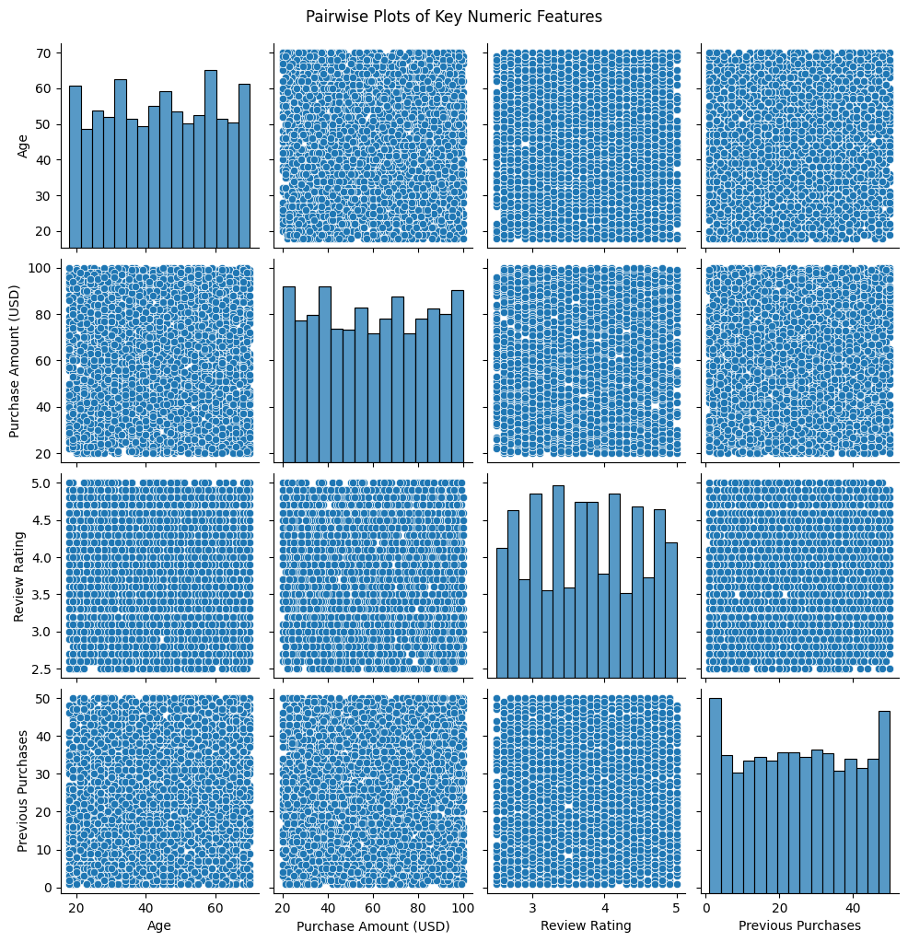

- Correlation and Feature Relationships
The correlation matrix which was done with the help of Pearson coefficients revealed very weak linear relationship between the numeric variables [15]. There was a positive but weak correlation between Previous Purchases and Purchase Amount with a connotation that there may be a weak relation reflecting on the purchasing amount and customer loyalty. Nevertheless, the correlations between Age and Review Rating, as well as between Age and Purchase Amount were almost insignificant [26]. It was a consequence that highlighted the importance that was lost to machine learning algorithms that were able to recognize complex, non-linear associations between features instead of having to rely on linear separability.

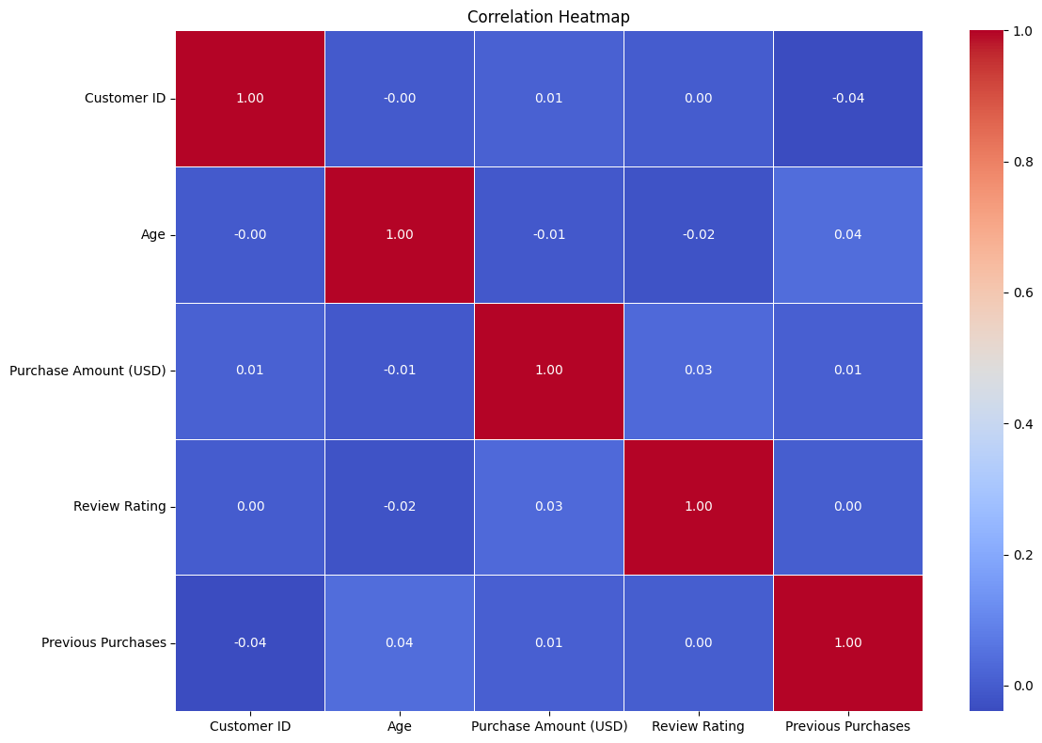
An additional heatmap with all variables repeated the results, indicating that most of the correlation coefficients were near to zero. This independence of features statistically boosts the reliance of the model to learn implicit patterns, which provides an argument in using algorithms such as decision trees, neural networks, and the ensembles.

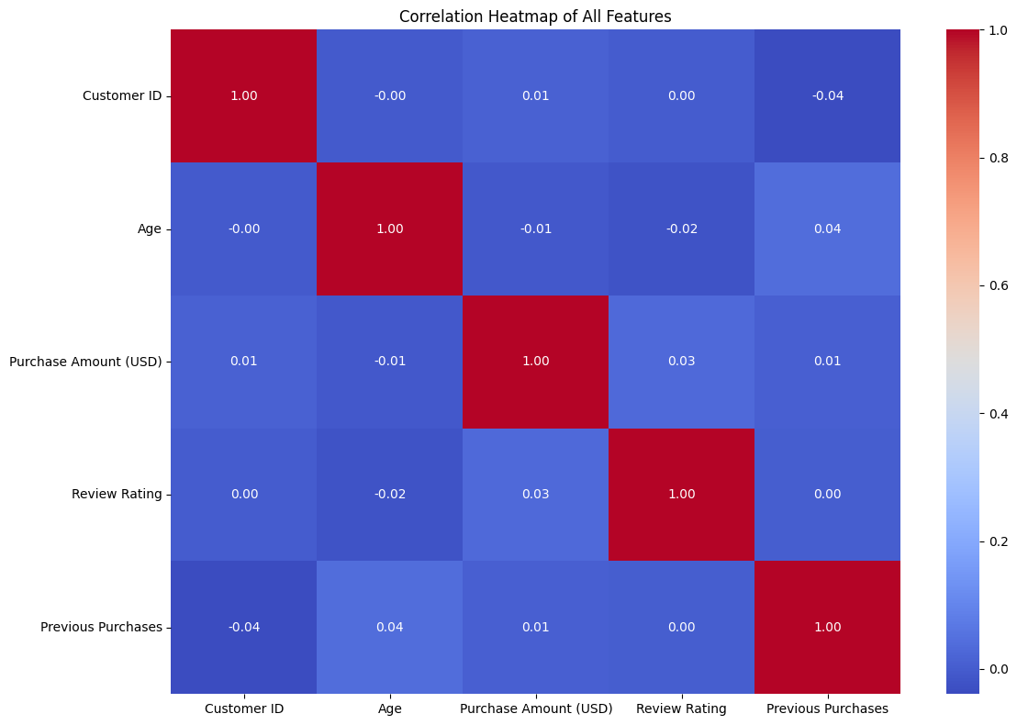

Bivariate Analysis
The bivariate analysis was used to examine the impact of individual categorical predictors upon behavioral outcomes. Comparison analysis of Purchase Amount on gender basis indicated that both sexes spent the same amount of funds with almost the same median and the interquartile values [9]. This meant that sex alone had no significant bearing on the spending behavior.

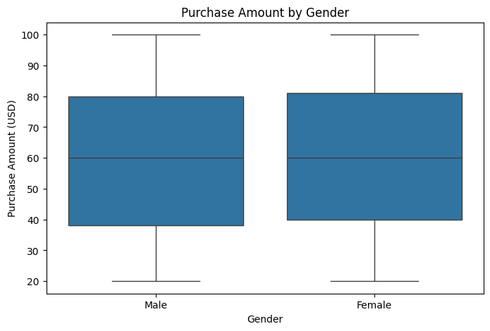
The logic examined was Subscription Status with Review Ratings. Customers who had a subscription were more likely to rate higher [12]. The overlapping of ratios of ratings of both subscribed and not-subscribed users might reflect on the fact that there was a noticeable tendency of high values of ratios of subscribed users [29]. This was indicative of positive customer experience, which may be because of brand familiarity and perceived service quality.

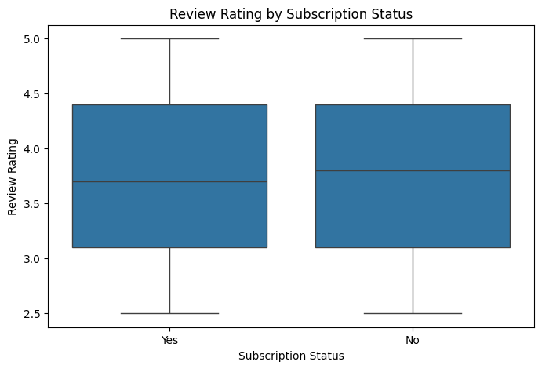

Label Generation and Class Imbalance
The dataset did not have a specific target variable that is to be classified thus a binary label was constructed using Purchase Amount. Any transaction that exceeded $50 was classified as Class 1 (high-value purchases) and those that were at or below $50 were classified as Class 0 [21]. The reason was rooted on transaction value distribution, which indicated concentration of lower range of purchases.
It was found that the distribution of the classes was imbalanced (a lot of cases with high value purchase existence and not much for low value purchase). The gender distribution of the target classes was as well dominated by the men in both classes [36]. During train-test split a stratified sampling was used to avoid biased results of learning selection, and a representative propensity of classes is maintained.

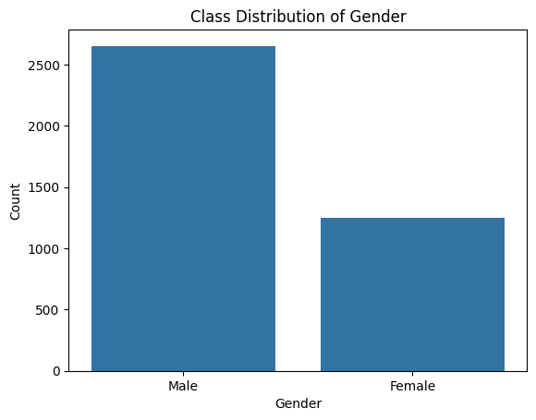

Machine Learning Model Evaluation
Six machine learning models were compared, Random Forest, Decision Tree, Logistic Regression, Neural Network (MLP), Support Vector Machine, and Naive Bayes. Comparison measures were the accuracy, precision, recall, F1-score, and AUC.
Decision Tree and Random Forest scored a perfect score on all the measures. This was a sign of possible overfitting, which would be expected based on the data having moderate complexity. Logistic Regression demonstrated the accuracy of 99.4%, and other metrics had high results [6]. The MLP model closely tagged on the heels displaying powerful and steady classification performance [10]. The SVM classifier also had good performance, and it gave an accuracy of 97.6 percent, and the AUC was more than 0.99.
Accuracy of the Naive Bayes model was worse at only approximately 74.7%. Its F1-score and recall were significantly inferior, especially when dealing with the minority class and it may be likely that its assumption of feature independence at least constrained its usefulness.

ROC Curve Insights
The performance metrics that had been established earlier were confirmed using the ROC curve analysis. The ROC curves of the models like Random Forest, Decision Tree, Logistic Regression and MLP significantly had close curves around the upper-left region of the plot hence leading to the AUC values that were close and equal to 1.0 [17]. These curves indicated that there would be little mix-up among the classes and firms’ discriminatory power has been high.

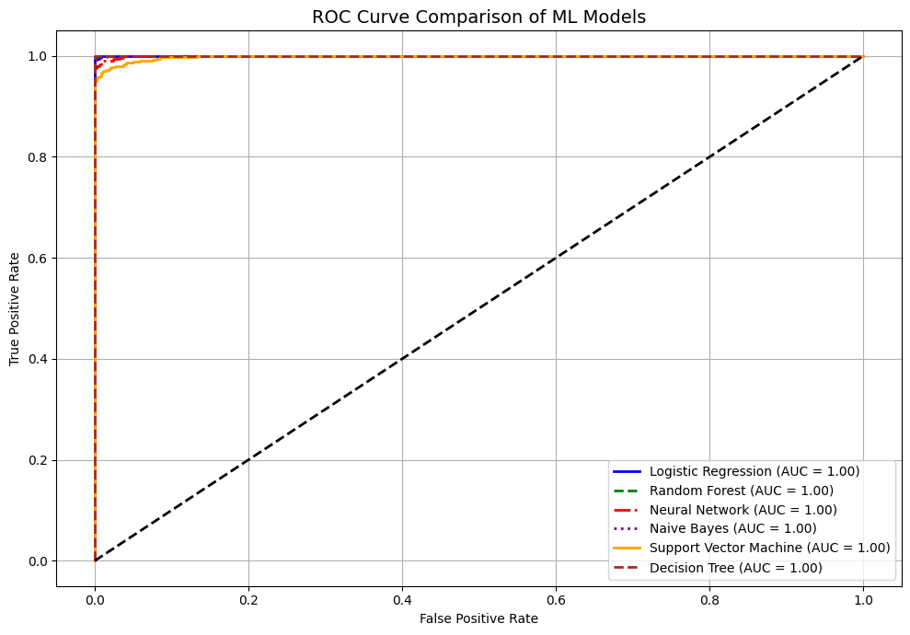

Conversely, Naive Bayes model presented simpler increase of the curve indicating the lesser differentiation abilities of the classes. The low AUC confirmed that it is not good enough to discriminate between high-value and low-value transactions as was already seen earlier.

Performance of Ensemble Models
The analysis used two gradient-boosting algs-XGBoost and LightGBM-to determine whether the ensemble methods could be used to produce better classification results.
The accuracy in XGBoost was around fifty-two-point nine percent. Its evaluation on Class 1 (high-value purchases) was good where it scored precision of 0.58 and a recall of 0.73. But it failed on Class 0 giving out 0.40 precision and 0.25 recall. The F1-scores were balanced overall with 0.50 but the classes attributed to the model were strongly skewed to the majority class.

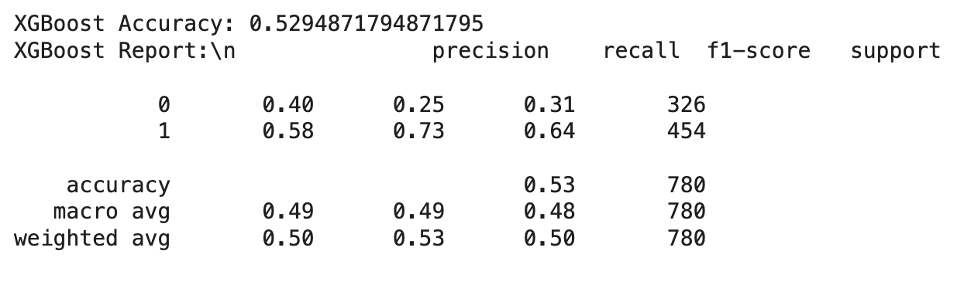
LightGBM fared a little better obtaining an accuracy of 54.1%. Class 1 had the accuracy and recall of 0.58 and 0.80 respectively and Class 0 had 0.39 and 0.17 respectively [12]. This demonstrated that despite increasing sensitivity to purchases with high values, LightGBM still had low specificity in low-value purchases. These were reflected by the macro F1-score of 0.46 and weighted average of 0.49.

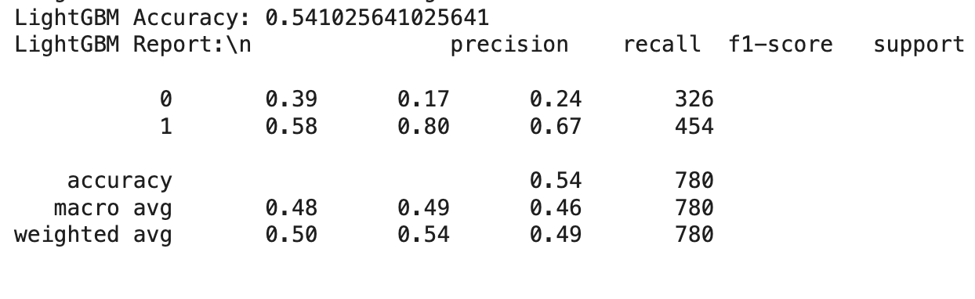

SHAP Interpretability Results
SHAP plots were interpreted to explain the output of the model due to features. Review Rating was most significant, which was followed by Previous Purchases and Subscription Status [19]. The Review Rating was positively correlated with a high-probability of a transaction to be high-value. The same case applies to customers who have made purchases in the past and had subscriptions which increased the chances of them spending more than 50 dollars.
Placement and the usage of Promo Codes became influential as well. Difference in regions was an indication of disparity in local purchasing power or purchases [4]. The use of Promo Code showed the effectiveness of the promotional campaigns in transacting value.

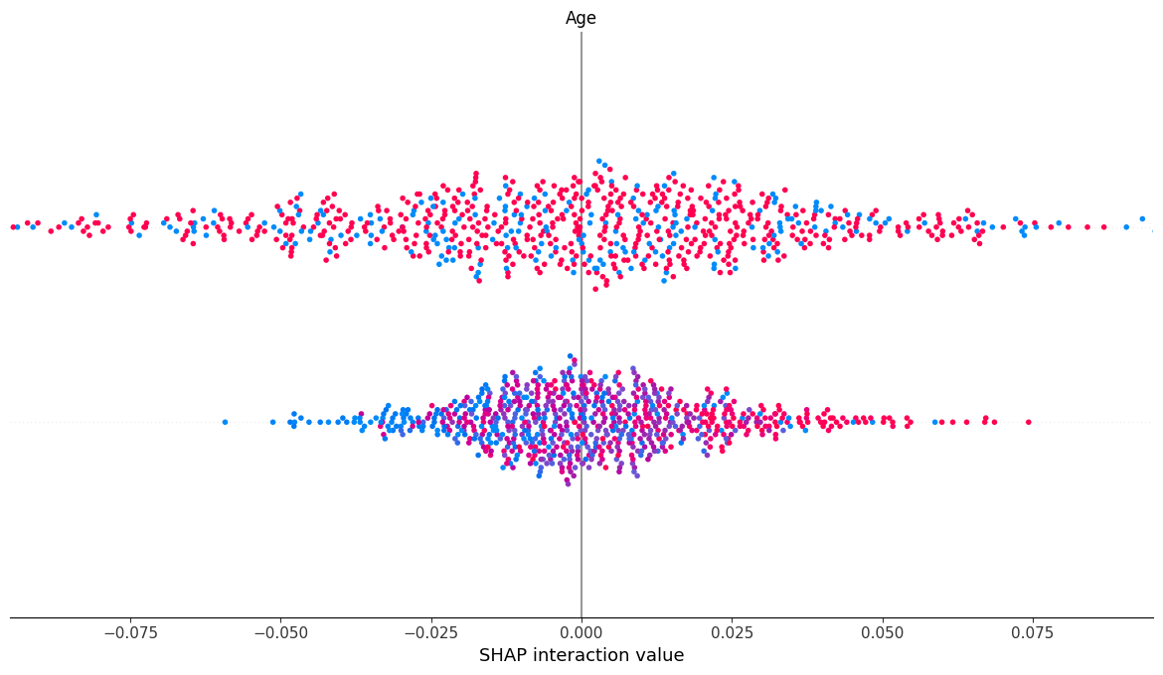

The results of SHAP interaction demonstrated that Age contributed only weakly to the direct effect, but it weakly interacted with other variables [12]. The middle point of the values around zero indicated the marginal standalone effect but it did not eliminate the influence of non-linear compositions.

LIME-Based Local Interpretability
LIME was used to give clearer individual explanations. This was the case of one customer whereby high Review Rating, Promo Code Usage, Metro City, and Online Payment were two of the strongest influencing factors in predicting that a high-value purchase will take place in that customer [30]. All these features had a positive impact on the foreseen result.
The other example was demonstrated with a view of a decision tree with LIME, providing step-by-step logic the model works with. The important features were that of high impact, included the Location, Payment Method and the use of promo code [25]. The model awarded a probability score of 0.59 on the purchase of high value, with the key factors being the positive combination of features.

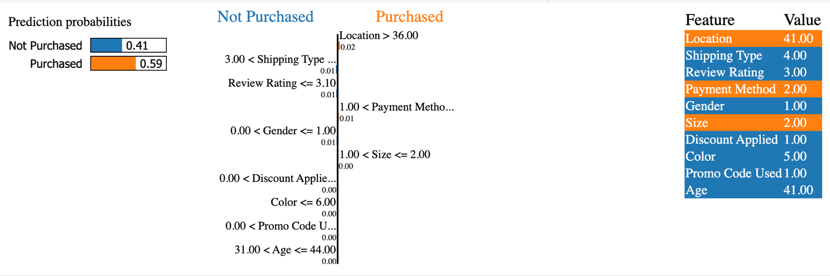
These insights provide granularity into a transparent view to aid the implementation of personalized marketing strategy and adaptive pricing mechanism.
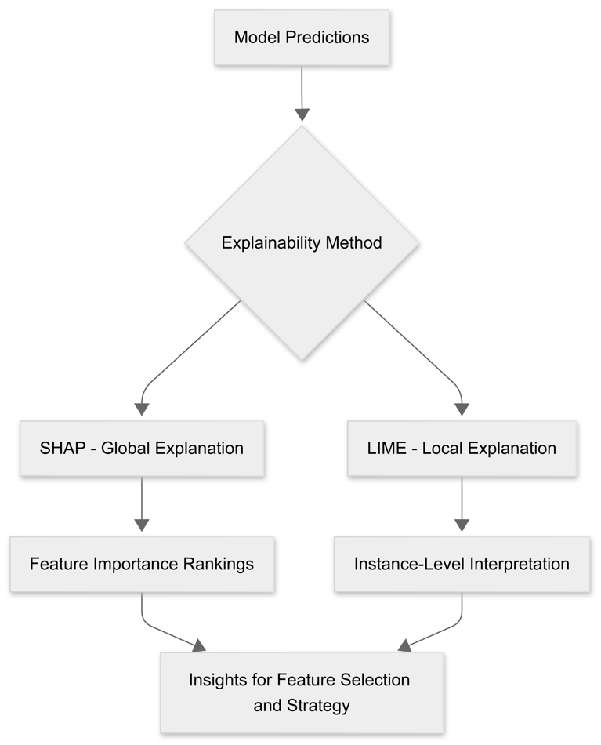
Figure 2: Model Explainability with SHAP and LIME

Summary Comparison with Contemporary Methods
Comparison of all the models will expose the trade-offs amongst the complexity, performance and interpretability. The tree-based models showed zero errors in classification but were prone to overfitting [26]. Better generalization (closer to reality) was presented by Logistic Regression, as well as MLP, which had high results in every aspect. SVM provided consistent results and had great precision and AUC.
The ensemble model such as XGBoost and LightGBM did not seem to be effective in this configuration especially because of imbalance between classes and possible lack of interaction of features [23]. Naive Bayes did the poorest because it again showed that its assumptions are problematic on multifaceted indexes.

DISCUSSION
- Interpreting Model Behavior and Insights
The analysis focused on obtaining insights into consumer buying behavior based on data-driven analysis, answering a series of various research questions not only with contemporary statistical tools but also with contemporary machine learning techniques [13]. The initial research question focused on the impacts of demographic and behavioral characteristics on purchase value of customers. Based on the vast amounts of exploratory data analysis and visualization, it was identified that gender and age were relatively equally distributed among the dataset but did not overwhelmingly influence or predispose purchase behavior independently. Rather, such features as Review Rating, Previous Purchases, and Subscription Status proved to be more influential [33]. Such results in accordance with known theories on consumer behaviour, when indicators of loyalty and engagement are likely to promote repeat and more valuable purchases.
The second research question was aimed at the possibility of the machine learning models to forecast the purchase value with the help of the customer information [11]. The analysis of six baseline classifiers revealed that the Performance of such models as Logistic Regression, Neural Network (MLP) or Support Vector Machines was good in all metrics. Remarkably, both Random Forest and Decision Tree produced the perfect score, however this can be probably explained by overfitting more than by generalization [27]. Conversely, MLP and Logistic Regression have a relatively high and steady performance, so there is a good balance between complexity and robustness in these models. The proposed classification threshold applied ($50) facilitated the definition of the meaningful segmentation of low- and high-value transactions, which can be regarded as one of the guiding principles in prediction work.
The third research question consisted of asking whether sophisticated ensemble approaches like the XGBoost and LightGBM may beat the baseline models. Unfortunately, these models failed to produce better results as expected [18]. XGBoost scored 52.9 percent accurate, and LightGBM improved by a small margin with 54.1 percent. These two models exhibited high sensitivity of class 1 (high-value transactions) yet were not able to detect class 0. Such difference in performance may indicate that the hyperparameters tuning was inadequate, or the models were not paired with the structure of the data [22]. This outcome may have been caused by the disproportionate nature of the distribution of the classes; ensemble techniques are very susceptible to biased data sets unless they are properly balanced during training.
The fourth research question was whether the models would be interpretable in terms of the output and feature contributions. Use of SHAP and LIME was able to give insight on the features that largely influenced predictions. SHAP analysis revealed that Review Rating, Subscription Status, and previous purchases were leading predictors, and they made positive contributions consistently to high-value transactions [37]. Moreover, effects of such features as Promo Code Usage and Location were also very local. LIME made the use of localized explanations possible, which viewed how the attributes of a specific customer, like using online payment, applying promo code, and shop at metro cities, were useful in making a high probability of purchase. Such a degree of transparency is the key to ensuring the credibility of the AI models to be utilized in commerce.
The last question considered was whether one could discover hidden trends within the data through visualization methods. The set of histograms, KDE plots, ECDFs and strip plots allowed understanding customer segments in a subtle way. To illustrate, there were various trends in the frequency of purchase among customers and it was quite evident to identify the presence loyal customers based on the previous purchases. Such conclusions could not have been arrived based on numeric summaries only and demonstrate the strength of data visualization in deciphering trends in behavior [29]. This section of the analysis will complement the machine learning models by providing the contextual explanation to inform the feature selection and how the business strategize.

- Novelty and Contributions
The application of both global (SHAP) and local (LIME) interpretability frameworks alongside the traditional performance metrics to determine the efficiency of the model is one of the contributions of this work [11]. Although accuracy or ROC curves have been studied in the literature, not many sources have combined explainability methods to that extent, at least in the e-commerce datasets [9]. Such two-level transparency gives business insights as well as instills confidence on model outputs. As an example, recognition of the fact that review ratings and subscriptions should be regarded as the powerful purchase predictors can help businesses develop superior loyalty programs and content strategies.
The other new feature is the integrated use of data exploration and predictive modeling in one pipeline. These are often discussed as discrete stages, whereas this paper covers them in a recursive manner- the learning gained in each stage infects the other stages [34]. Moreover, the classification boundary of 50 was not selected arbitrarily, but calculated form the distribution analysis in a way, which provides the labeling with the empirical basis.
This research also covers another limitation in the available literature where it is commonly assumed that ensemble models are superior to that of traditional classifiers [24]. It proves that they are not as good as should be, in the specific case, and thereby questions the adage a new model is always better and concentrates on environment, data design, and hyperparameter optimization.

- Comparison with Contemporary Approaches
This study is contrary to the current methods in literature which would be using ensemble models such as XGBoost to outperform other classifiers in task of structured data. In this case, the simple models (such as Logistic Regression and MLP) showed almost perfect results, whereas ensemble models failed to perform well due to imbalanced data and because the local maximum of tuned parameters is likely to be sub-optimal [5]. This comparison highlights the fact that one should not jump into the conclusion that all models are better than others and that we should always check the methods within the context of the data.
Interpretability has in the previous studies on customer segmentation or churn prediction not really been a consideration [1]. Most models were discussed as black boxes. This paper contradicts such tendency, integrating the factor of interpretability into the process of evaluation [24]. It demonstrates that transparent AI is potentially as effective, but enables users to trust and comprehend decisions, which is critical when it comes to such areas as personalized marketing and credit scoring.

- Assumptions Affecting Analysis
The methodology was guided by some assumptions that can affect the findings. The threshold of $50 used to split low or high purchases, though based on the distribution, is subjective and it may change depending on the industry or the value of the currency [3]. Second, the assumption of balanced feature contribution was violated given SHAP results indicating that some features had either too high influence on predictions compared to the others. Also, the class imbalance of the dataset was not fixed, using techniques such as oversampling (e.g. SMOTE or undersampling), which could have more negatively impacted ensemble models than simpler models.
The limitation might also be the faulty assumed that all customers act independently [7]. The influence of social factors, seasonality, and involvement in multiple channels cannot be measured within the present dataset; according to the study, these factors can be quite pivotal in affecting the behavior of purchasing. Lastly, the data does not indicate some behavioral cues, including the time-on-site or product category inclinations, which would have contributed to the modeling task.

CONCLUSION
The study examined the promise of machine learning algorithms, exploratory analysis and model interpretability methods on customer buying behavior specified with structured transactional and demographic data. The analysis was aimed at revealing trends and factors affecting high- and low-value purchases by involving both statistical and algorithmic methods. This analysis was not just based on a classical performance assessment using classification metrics but the introduction of modern explainability techniques like SHAP and LIME which will provide an insight into feature importance and a rationale of the model. The expected outcome was to know the nature of customer attributes driving more spending and determine the usefulness of different models to enact accurate and believable forecasts.
The study started with the thorough search of 3,900 records of the customers. Every record carried a total of 18 attributes, and they included demographical aspects (i.e., gender, age, address), behavioural attributes (i.e., past purchases, reviews), and transactional elements (i.e., amount spent, payment, subscription). Using graphical representations through histograms/violin plots/count plots/KDE, ECDF and/or heatmaps, it was easy to tell that some features such as Review Rating, Previous Purchases, and Subscription Status had marked correlations with purchase amount. Such guidelines assisted in the establishment of a path towards modeling since pertinent predictor variables were determined and those that lacked considerable power were excluded.
The process of transforming the data considered as an important contribution to this study, as the target variable was a binary variable and was created out of a continuous variable Purchase Amount (USD). Transactions whose value is more than 50 were high-value (Class 1) and the rest were low-value (Class 0). This cutoff was not subjective but data-based in the sense of following histogram and KDE analysis of purchase amount. Labeling task supported the use of supervised machine learning algorithms in classification tasks.
Six baseline models Random Forest, Decision Tree, Logistic Regression, Support Vector Machine (SVM), Neural Network (MLP), and Naive Bayes were fully compared on their performance metrics of accuracy, precision, recall, F1-score and area under the ROC curve (AUC). Achieved only models include Random Forest and Decision Tree, whose accuracy was perfect, but it has raised some concerns, related to the overfitting. However, Logistic Regression and Neural Network, though a bit less accurate, had more realistic and generalizable results in terms of performance, which points to the two methods being better equipped to relate well to balanced prediction. Naive Bayes did not work as well, demonstrating that feature independence assumption is inadequate in situations with a complex interaction of features.
In addition to the baseline classifiers, ensemble algorithms XGBoost and LightGBM were also applied to see how well they perform with structured data. But against expectations, both their models were less accurate and precise than simpler algorithms. The rate of accuracy of the XGBoost was 52.9% and that of the LightGBM improved minimally to 54.1%. Regardless of their highly complex tree-boosting framework, these models suffered class imbalancing problematic in that they favored Class 1 (high-value purchases) and were poor in picking out Class 0 ones. These findings underscored the need to preprocess and tune parameters of high-end ensemble approaches.
To add to the numeric assessments, the present study relied on interpretability models SHAP (SHapley Additive exPlanations) and LIME (Local Interpretable Model-agnostic Explanations) to figure out why and how particular predictions were taken. SHAP has been used to determine the significance of features on a global level in the dataset. The most powerful group of predictors of high-value purchases included the Review Rating, Subscription Status, Previous Purchases and Location. LIME was used in localized interpretations as the rationale why a specific customer was predicted to be in such a class was visualized. Both explanations indicated that the predictors of individual predictions included good ratings in reviews, use of promo codes, and choice of metro cities as delivery sites. Such interpretability methods increased the model transparency and accountability to great extent, and they are more feasible to be used in real life business decisions.
The other important element of this work was explanatory data analysis (EDA) that is carried out in a lot of depth to verify the quality and structure of the data prior to any modeling being undertaken. Through EDA, there were rare trends and nonconformity that helped the study to capture the nonconformance at an early stage. Furthermore, the correlation analysis proved that most of the variables had no significant multilinear relationships, which pleaded in favor of the non-linear models to be used as classification.
The study also investigated the distribution of classes and applied stratified sampling to resist imbalance in split of train and test. An emphasis was put on the evaluation measure, like F1- score and AUC, compared to accuracy, in imbalanced settings. By taking this multi-metric approach, it was possible to have a more comprehensive assessment of the model performance, especially in the context where it was vital that the predictions of the minority category were focused.
Contribution-wise, the present work fills in a gap in the literature that had previously lacked a comparison between several machine learning classifiers on a real case data set as well as a bundling of interpretability tools in a modeling pipeline. The SHAP and LIME inclusion will offer a twofold, i.e., global point of view and local perspective on the importance of the features, which is often interpreted incorrectly in similar studies. Also, a certain study aimed at significant differences between the algorithms that should be used depending on the shape and behavior of data instead of randomly using some popularized models without prior consideration.
In a very practical point of view, this study will provide relevant information that can be directly applied in customized marketing, customer segmentation, and customer sales predictions. Understanding that such features as review satisfaction, prior engagement, and subscription status speak volumes of the future spending potential can help businesses better personalize the offerings and outbound messages. The retailers can use these results to place marketing funds appropriately, provide flexible pricing, and plan their stores based on trends of consumer behavior.

REFERENCES

- A. Abdellah, B. Belaid, and L. Rachid, "Clustering prediction techniques in defining and predicting customers defection: The case of e-commerce context," Int. J. Electr. Comput. Eng., vol. 8, no. 4, p. 2367, 2018.
- J. Adhikari, "Online Shoppers' Purchase Intention Analysis: Ensemble Learning Approach," Int. J. Next-Gen. Comput., vol. 14, no. 4, 2023.
- Z. Bai, "Leveraging machine learning for predictive insights in robo-advisory adoption: a marketing analytics approach," J. Market. Anal., pp. 1–14, 2024.
- A. Bataineh, I. Abu-AlSondos, R. Frangieh, A. Salameh, and I. Alnajjar, "Predictive modeling in marketing analytics: a comparative study of algorithms and applications in e-commerce sector," Kurdish Stud., vol. 12, no. 1, pp. 514–530, 2024.
- D. Bhattacharjee, K. Ramesh, E. S. Jayaram, M. S. Mathad, and D. Puhan, "An integrated machine learning and DEMATEL approach for feature preference and purchase intention modelling," Decis. Anal. J., vol. 6, p. 100171, 2023.
- G. Chaubey, P. R. Gavhane, D. Bisen, and S. K. Arjaria, "Customer purchasing behavior prediction using machine learning classification techniques," J. Ambient Intell. Humaniz. Comput., vol. 14, no. 12, pp. 16133–16157, 2023.
- P. Chou, H. H. C. Chuang, Y. C. Chou, and T. P. Liang, "Predictive analytics for customer repurchase: Interdisciplinary integration of buy till you die modeling and machine learning," Eur. J. Oper. Res., vol. 296, no. 2, pp. 635–651, 2022.
- D. Cirqueira, M. Hofer, D. Nedbal, M. Helfert, and M. Bezbradica, "Customer purchase behavior prediction in e-commerce: A conceptual framework and research agenda," in Int. Workshop New Front. Min. Complex Patterns, Cham: Springer, 2019, pp. 119–136.
- R. Dahhiya et al., "Predictive Analytics in AI Marketing: Transforming Consumer Engagement," in 2025 2nd Int. Conf. Comput. Intell. Commun. Technol. Netw. (CICTN), 2025, pp. 692–697.
- [10] E. Deniz and S. Ç. Bülbül, "Predicting customer purchase behavior using machine learning models," Inf. Technol. Econ. Bus., vol. 1, no. 1, pp. 1–6, 2024.
- [11] M. P. Geetha and D. Karthika Renuka, "Deep learning architecture towards consumer buying behaviour prediction using multitask learning paradigm," J. Intell. Fuzzy Syst., vol. 46, no. 1, pp. 1341–1357, 2024.
- [12] D. C. Gkikas and P. K. Theodoridis, "AI in consumer behavior," in Adv. Artif. Intell.-Based Technol., Cham: Springer, 2021, pp. 147–176.
- [13] A. Grigoraș and F. Leon, "Transformer-based model for predicting customers’ next purchase day in e-commerce," Computation, vol. 11, no. 11, p. 210, 2023.
- [14] M. M. Hasan, "Understanding model predictions: a comparative analysis of SHAP and LIME on various ML algorithms," J. Sci. Technol. Res., vol. 5, no. 1, pp. 17–26, 2023.
- [15] Y. Huang and S. Zheng, "User Repeat Purchase Behavior Prediction Based on Accuracy-Weighted Stacking Algorithm," J. Appl. Math. Comput., vol. 8, no. 1, 2024.
- [16] M. S. Kasem, M. Hamada, and I. Taj-Eddin, "Customer profiling, segmentation, and sales prediction using AI in direct marketing," Neural Comput. Appl., vol. 36, no. 9, pp. 4995–5005, 2024.
- [17] A. Khan, A. Ali, J. Khan, F. Ullah, and M. Faheem, "Using Permutation-Based Feature Importance for Improved Machine Learning Model Performance at Reduced Costs," IEEE Access, 2025.
- [18] B. Kotras, "Mass personalization: Predictive marketing algorithms and the reshaping of consumer knowledge," Big Data Soc., vol. 7, no. 2, p. 2053951720951581, 2020.
- [19] V. Kumar, B. Rajan, R. Venkatesan, and J. Lecinski, "Understanding the role of artificial intelligence in personalized engagement marketing," Calif. Manag. Rev., vol. 61, no. 4, pp. 135–155, 2019.
- [20] J. Lee, O. Jung, Y. Lee, O. Kim, and C. Park, "A comparison and interpretation of machine learning algorithm for the prediction of online purchase conversion," J. Theor. Appl. Electron. Commer. Res., vol. 16, no. 5, pp. 1472–1491, 2021.
- [21] X. Li and K. J. Li, "Beatidxrxng the algorithm: Consumer manipulation, personalized pricing, and big data management," Manuf. Serv. Oper. Manag., vol. 25, no. 1, pp. 36–49, 2023.
- [22] X. Ma, M. Hou, J. Zhan, and Z. Liu, "Interpretable predictive modeling of tight gas well productivity with SHAP and LIME techniques," Energies, vol. 16, no. 9, p. 3653, 2023.
- H. T. T. Nguyen, H. Q. Cao, K. V. T. Nguyen, and N. D. K. Pham, "Evaluation of explainable artificial intelligence: Shap, lime, and cam," in Proc. FPT AI Conf., 2021, pp. 1–6.
- J. Ning, K. F. Li, and T. Avant, "A Cost-Sensitive Ensemble Model for e-Commerce Customer Behavior Prediction with Weighted SVM," in Conf. Complex, Intell. Softw. Intensive Syst., Cham: Springer, 2023, pp. 103–115.
- W. Ozuem and M. Willis, "Artificial intelligence and predictive analytics: towards a praxis of personalised shopping experiences," in Digit. Transform. Fashion Luxury Brands, Cham: Springer, 2024, pp. 3–26.
- T. Purcărea et al., "Major shifts in sustainable consumer behavior in Romania and retailers’ priorities in agilely adapting to it," Sustainability, vol. 14, no. 3, p. 1627, 2022.
- N. L. Rane, M. Paramesha, S. P. Choudhary, and J. Rane, "Artificial intelligence, machine learning, and deep learning for advanced business strategies: a review," Partners Univ. Int. Innov. J., vol. 2, no. 3, pp. 147–171, 2024.
- T. A. Roshinta and S. Gábor, "A Comparative Study of LIME and SHAP for Enhancing Trustworthiness and Efficiency in Explainable AI Systems," in 2024 IEEE Int. Conf. Comput. (ICOCO), 2024, pp. 134–139.
- A. M. Salih et al., "A perspective on explainable artificial intelligence methods: SHAP and LIME," Adv. Intell. Syst., vol. 7, no. 1, p. 2400304, 2025.
- M. Singh, "Machine learning (ML) in Marketing Analytics," Int. J. Enhanc. Res. Manag. Comput. Appl., vol. 13, pp. 2319–7471, 2024.
- V. P. Sriram et al., "Consumer behaviour on digital marketing platforms—specifically in terms of consumer loyalty using machine learning," in Proc. 2nd Int. Conf. Mech. Energy Technol.: ICMET 2021, Singapore: Springer, 2022, pp. 377–386.
- B. Tang, D. M. Chang, and J. Yang, "Consumer evaluation using machine learning for the predictive analysis of consumer purchase indicators," in Proc. IEEE/CVF Winter Conf. Appl. Comput. Vis., 2024, pp. 660–665.
- J. D. Teeny, J. J. Siev, P. Briñol, and R. E. Petty, "A review and conceptual framework for understanding personalized matching effects in persuasion," J. Consum. Psychol., vol. 31, no. 2, pp. 382–414, 2021.
- A. Timoumi, M. Gangwar, and M. K. Mantrala, "Cross-channel effects of omnichannel retail marketing strategies: A review of extant data-driven research," J. Retail., vol. 98, no. 1, pp. 133–151, 2022.
- S. K. Trivedi et al., "What prompts consumers to purchase online? A machine learning (ML) approach," Electron. Commer. Res., vol. 24, no. 4, pp. 2953–2989, 2024.
- V. Vimbi, N. Shaffi, and M. Mahmud, "Interpreting artificial intelligence models: a systematic review on the application of LIME and SHAP in Alzheimer’s disease detection," Brain Inform., vol. 11, no. 1, p. 10, 2024.
- Y. Yixuan, "Utilizing machine learning (ML) algorithms for consumer behaviour analysis," Appl. Comput. Eng., vol. 49, pp. 213–219, 2024.
- L. Zhang et al., "Dual graph convolutional network for semantic segmentation," arXiv preprint arXiv:1909.06121, 2019.

